**Capstone Project:**

**NMS Cinema**

**Document contains:**

* Project and developer details
* Sprints planned and the tasks achieved in them
* Core concepts used in the project
* Links to the GitHub repository to verify the project completion

**Project and developer details**

**DESCRIPTION**

Create a dynamic and responsive Java e-healthcare web application for ordering medicines of different categories.

Background of the problem statement:

NMS Cinemas is a chain of single screen theatres that screen movie shows of different genres and languages at very genuine prices. It was established in 2004 in Pune, India. Recently, the business analysts noticed a decline in sales since 2010. They found out that the online booking of movie tickets from apps, such as BookMyShow and Paytm were gaining more profit by eliminating middlemen from the equation. As a result, the team decided to hire a Full Stack developer to develop an online movie ticket booking web application with a rich and user-friendly interface.  
You are hired as the Full Stack Java developer and are asked to develop the web application. The management team has provided you with the requirements and their business model so that you can easily arrange different components of the application.

Features of the application:

1. Registration
2. Login
3. Payment gateway
4. Searching
5. Filtering
6. Sorting
7. Dynamic data
8. Responsive and compatible with different devices

**Admin Portal:**  
The admin portal deals with all the backend data generation and product information. The admin user should be able to:

Add or remove movie details from the application to build a rich product line

Edit movie details like name, price, screen no, starring, and offers to keep the product information updated with the current prices

Enable or disable a movie

**User Portal:**  
It deals with the user activities. The end-user should be able to:

Sign-in to the application to maintain a record of activities

Search for movies based on the search keyword

Apply filters and sort results based on different cuisines to get the best deals

Add all the selected movies to the cart and customize the purchase at the end

Perform a seamless payment gateway

Get an order summary details page once the payment is complete

**Developer Details**: Mogili Santhi

Santhimogili3@gmail.com

**Sprints planned and the tasks achieved in them**

There are four sprints for this project

Sprint-1: Studied the Features of application and created Git Repository.

Sprint-2: Movieplan backend created using spring boot and tested backend API

Sprint-3: Movieplan frontend created using spring boot and connected with backend.

Sprint-4: Movieplan application all features is tested.

**Recommended technologies**

Database management: MySQL

Backend development: Java programming, Eclipse, Spring Boot

Frontend development: JSP, Angular, Bootstrap, HTML/CSS.

**Output**

1. **Starting of backend Spring Boot Application.**

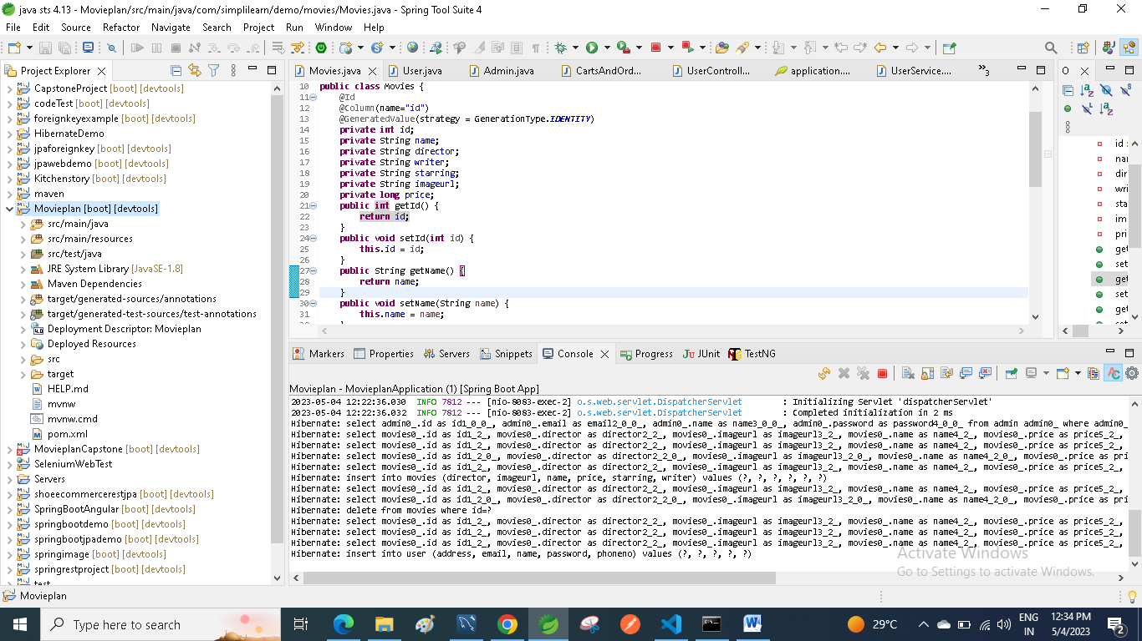

1. **opening of vs code.**

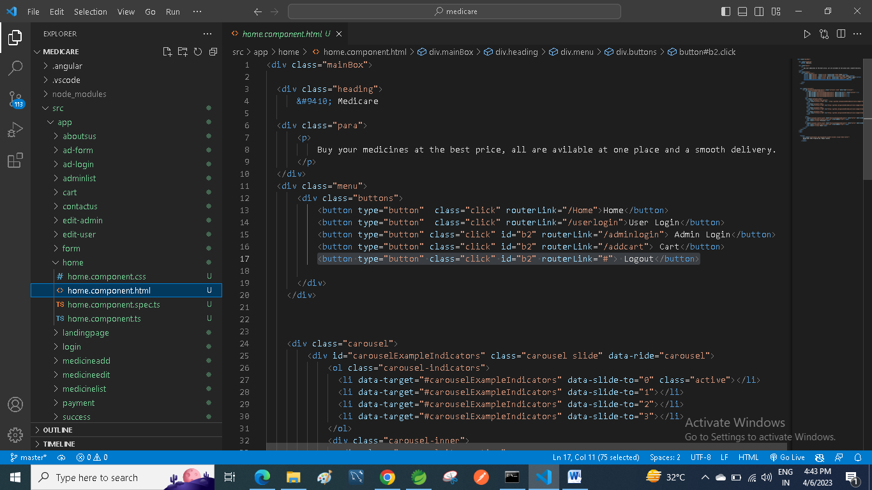

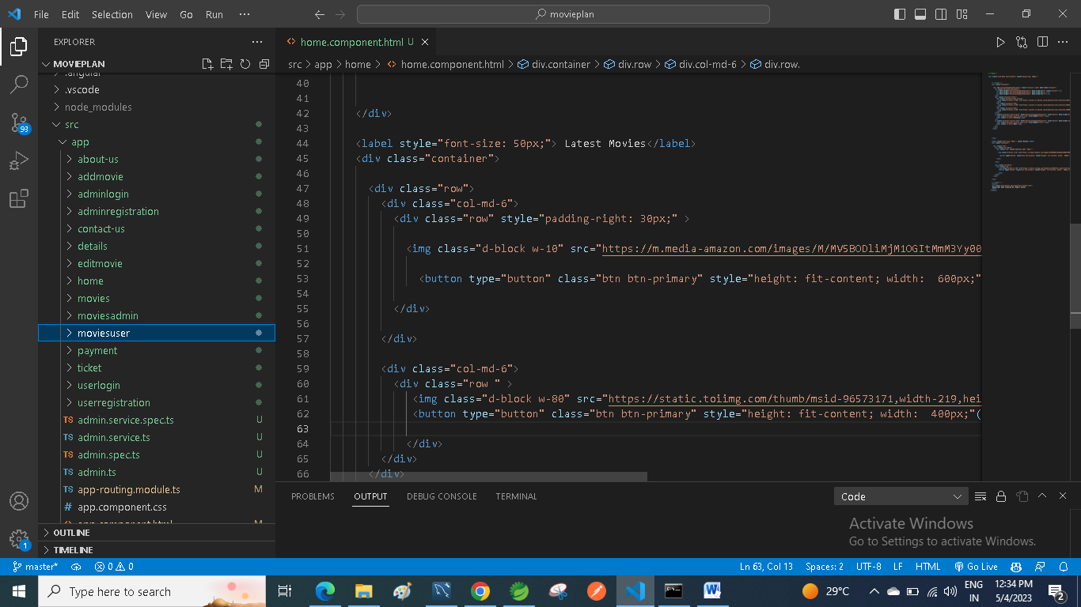

1. **opening the path in cmd and using ng serve code to start angular frontend application and Running localhost:4200/userhome url and Home page is opened.**

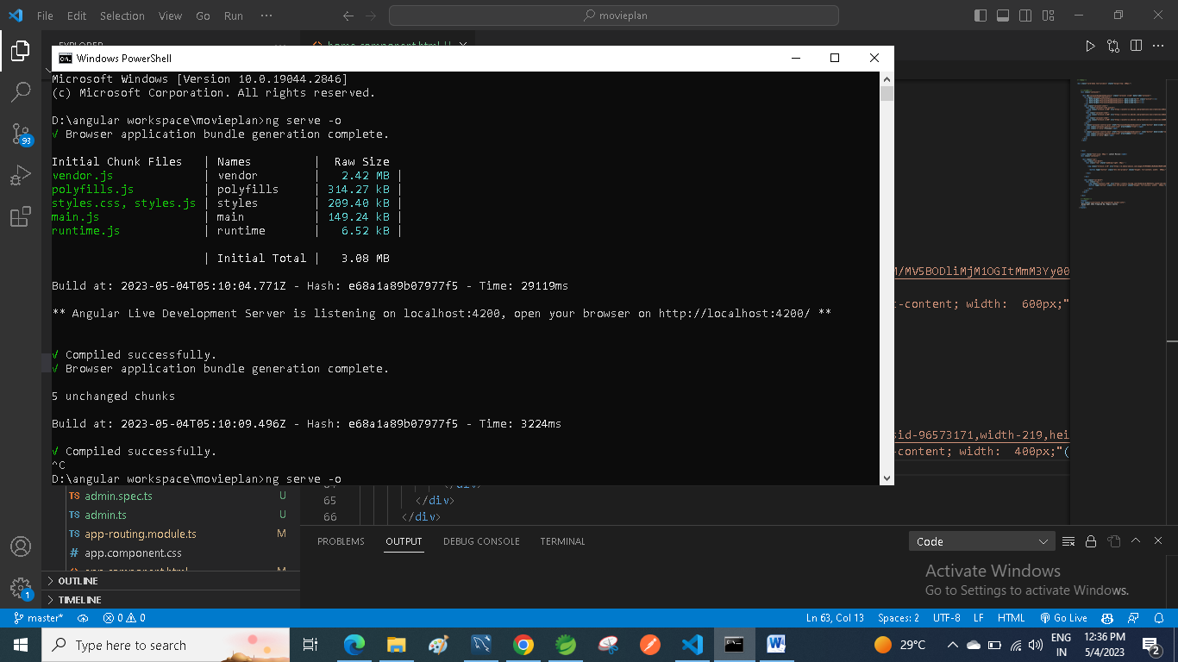

1. **Home page are shown in the website application.**

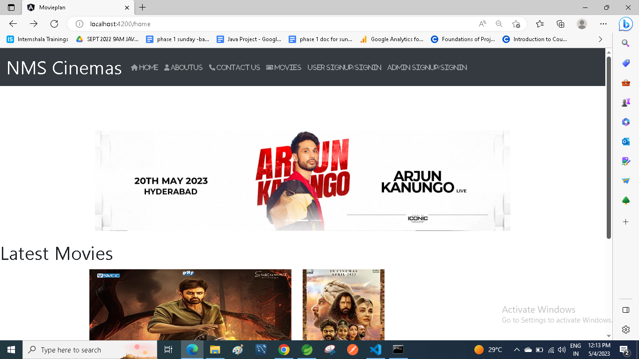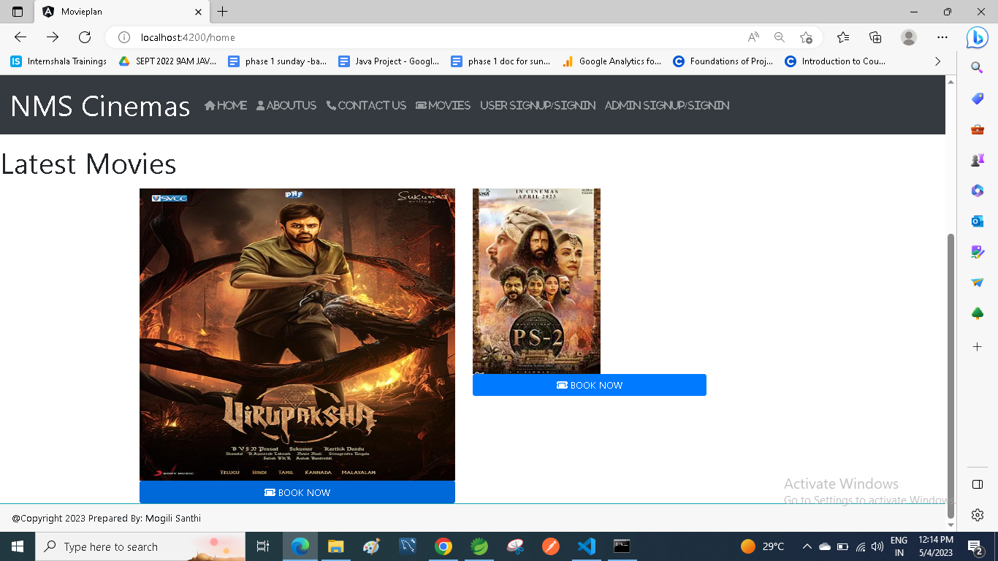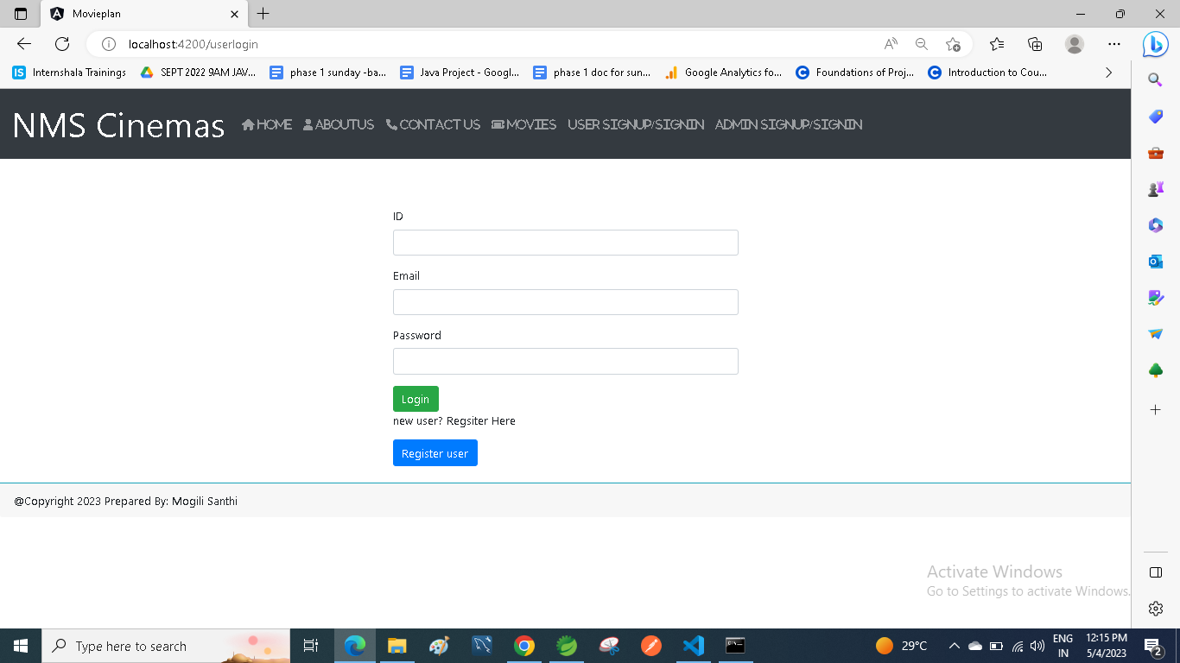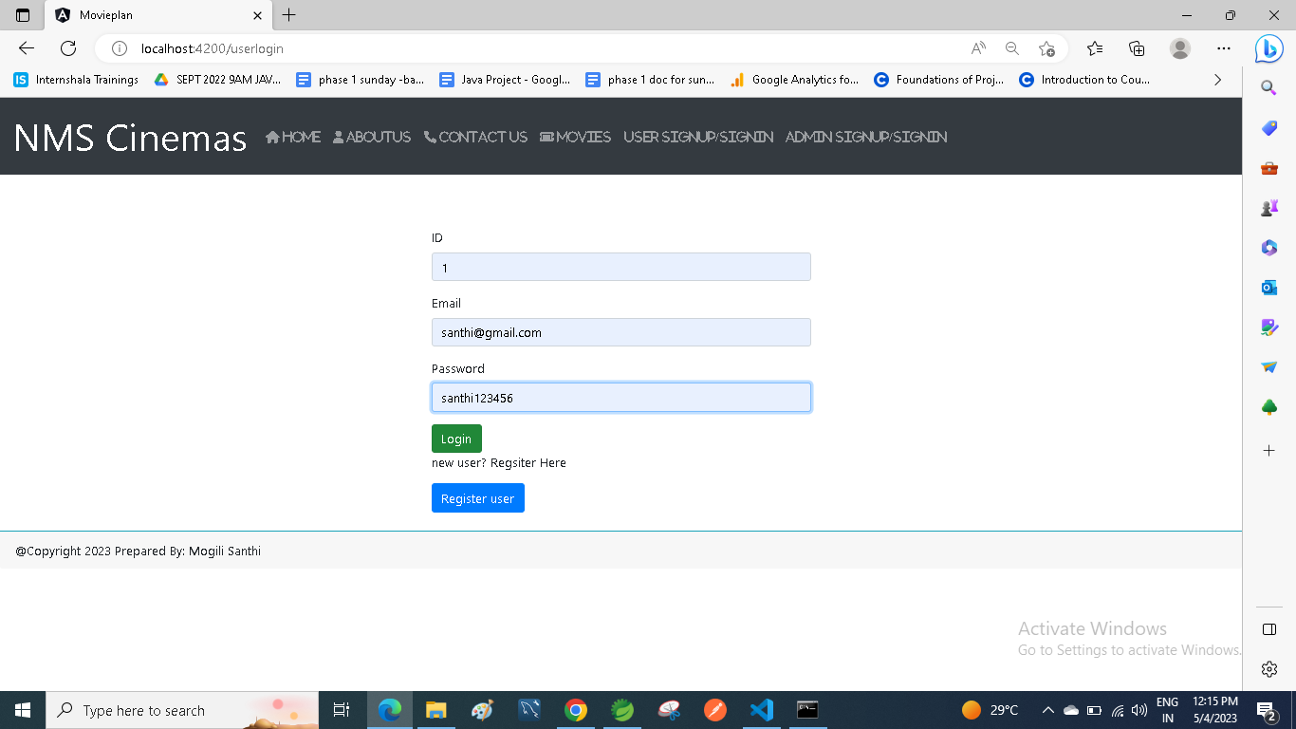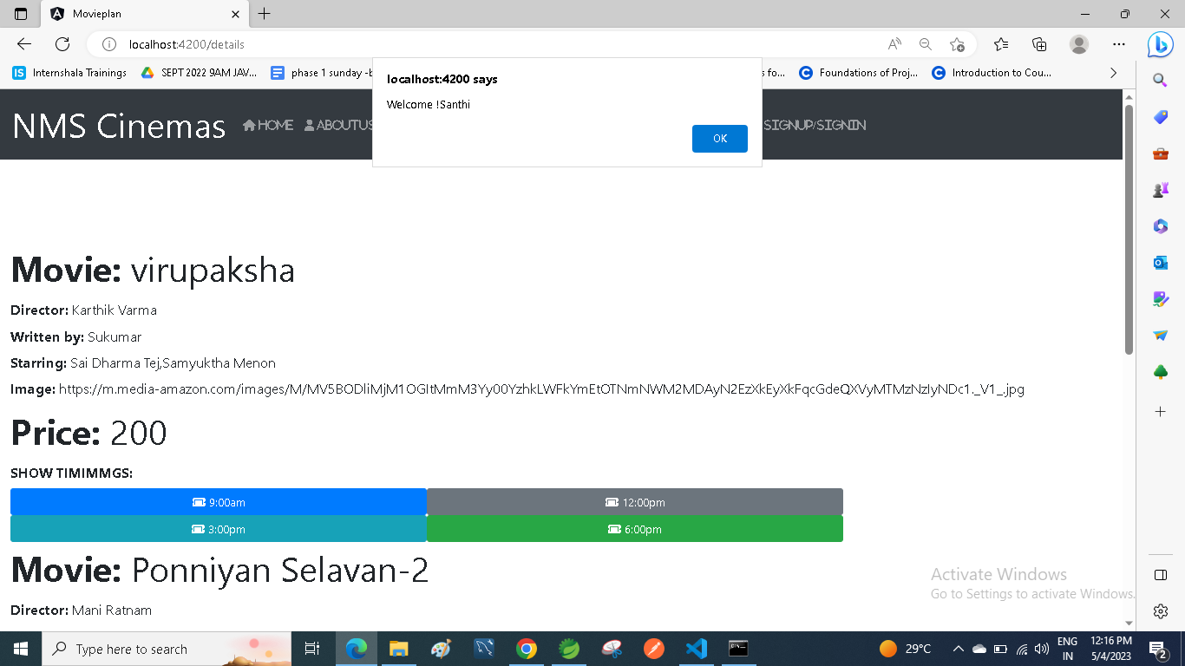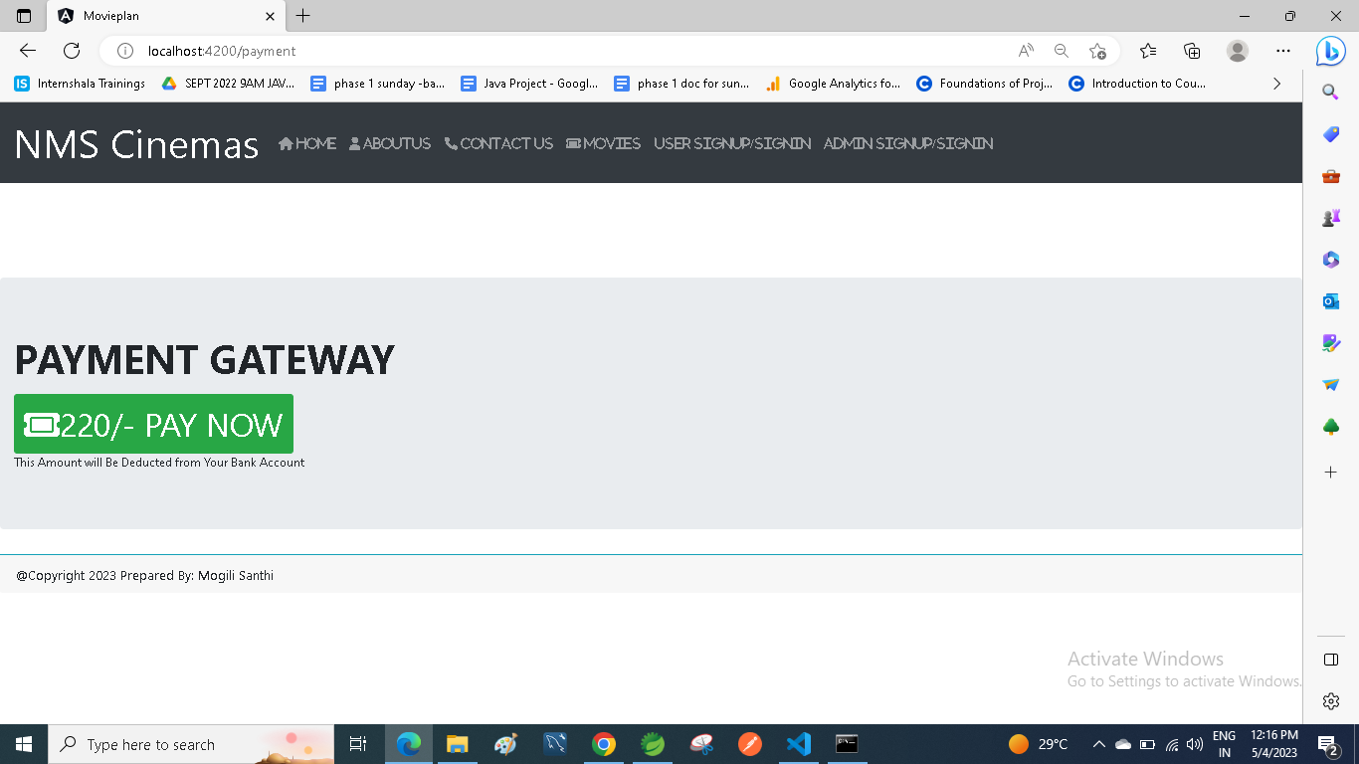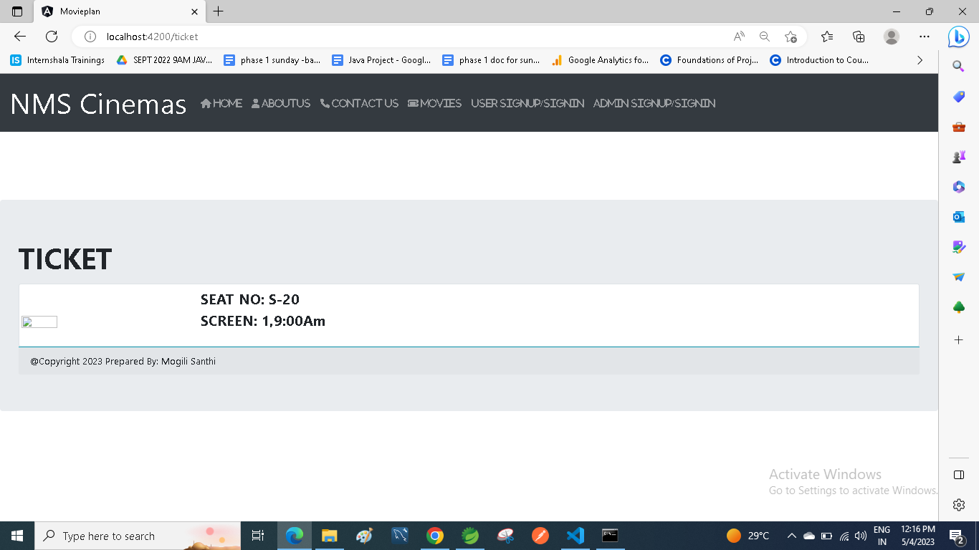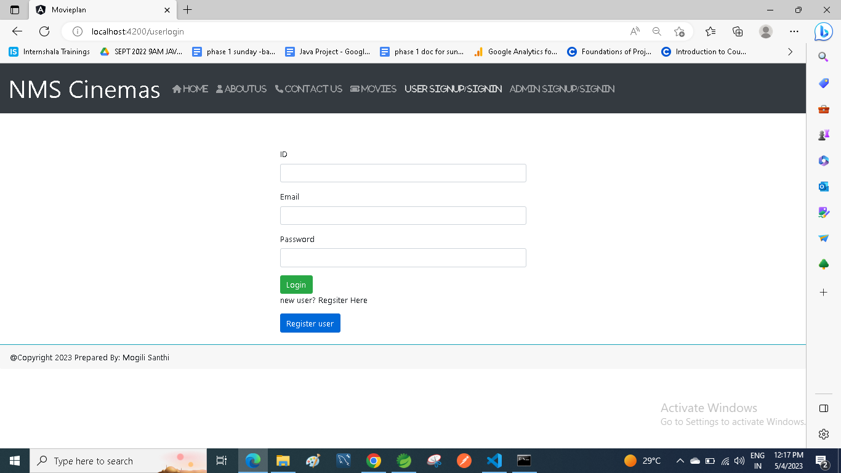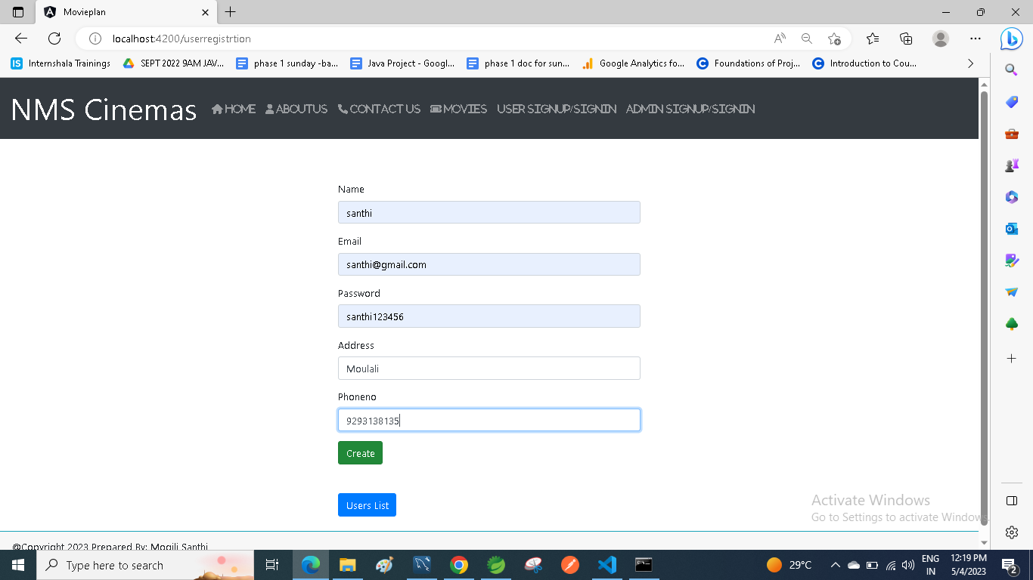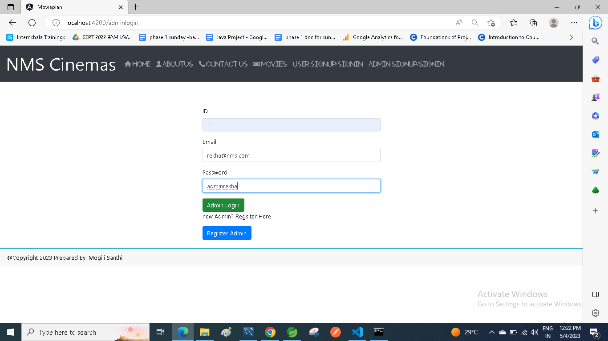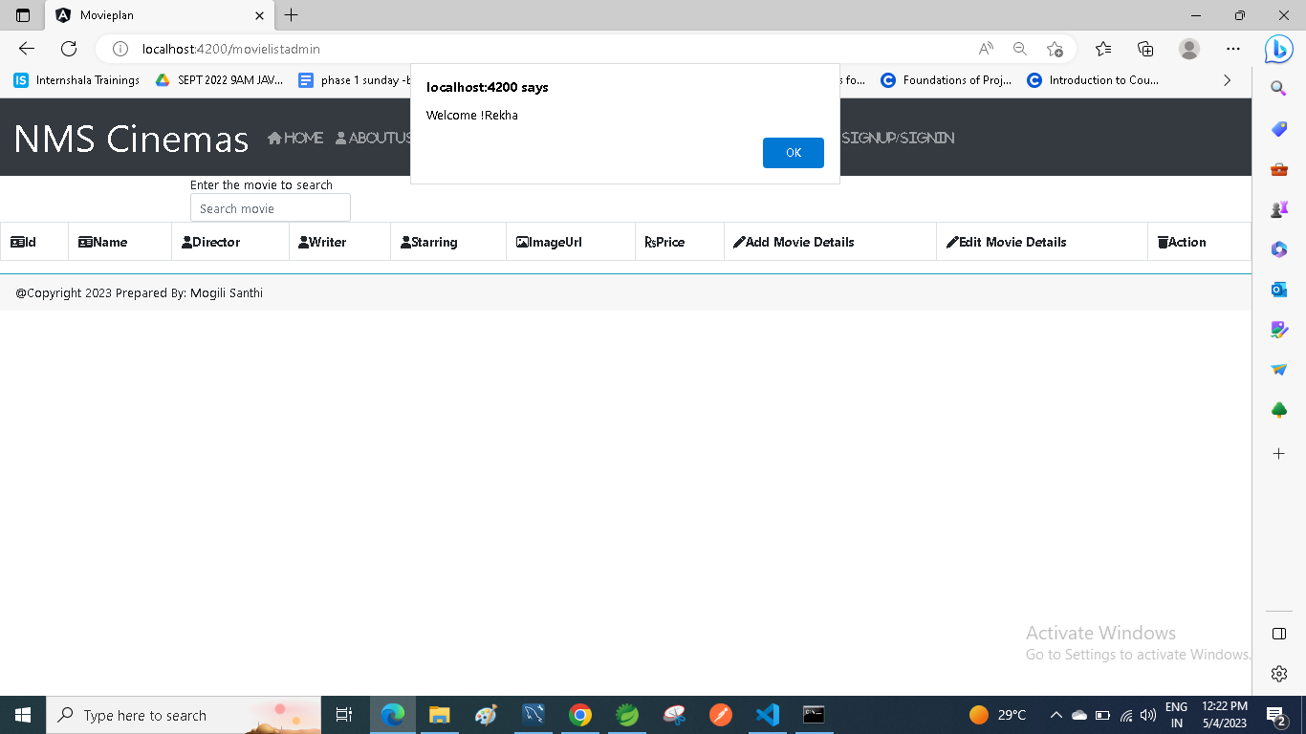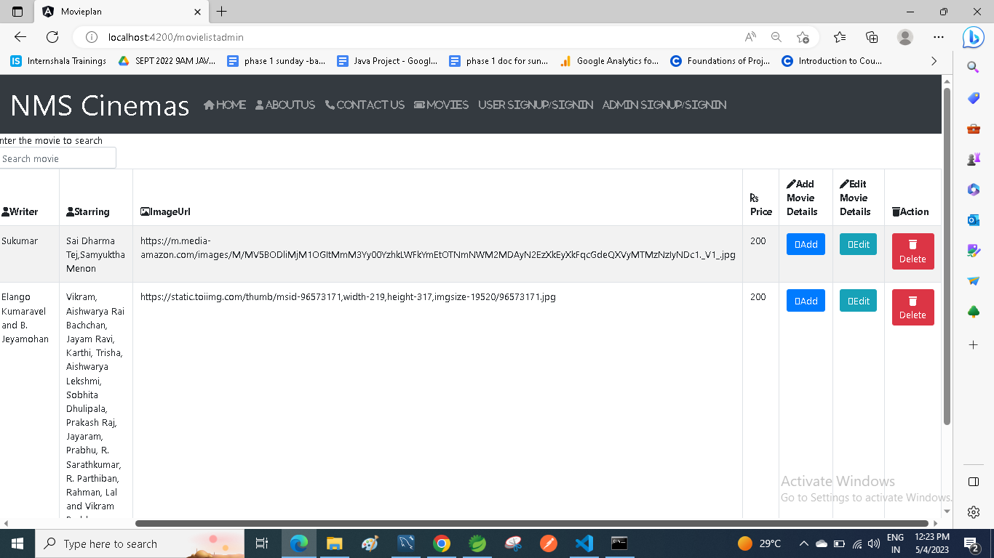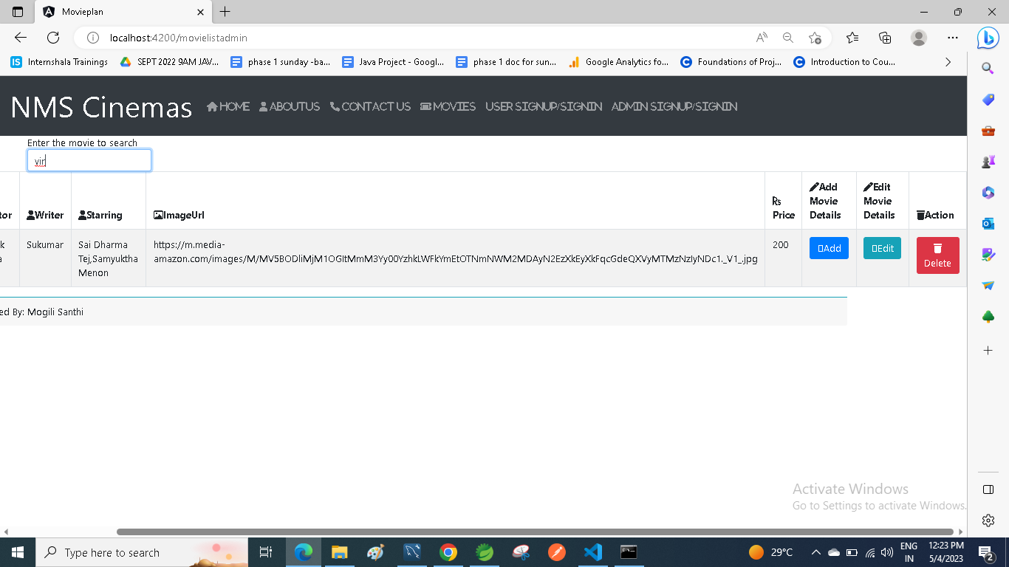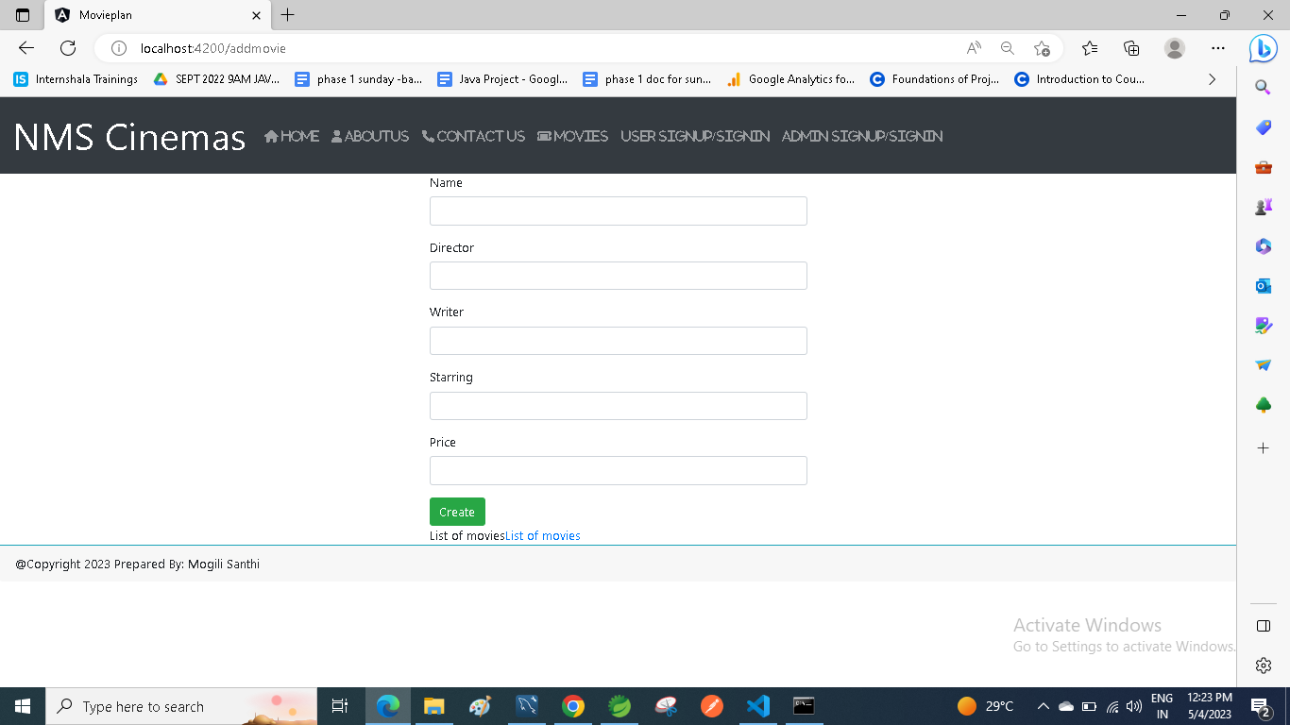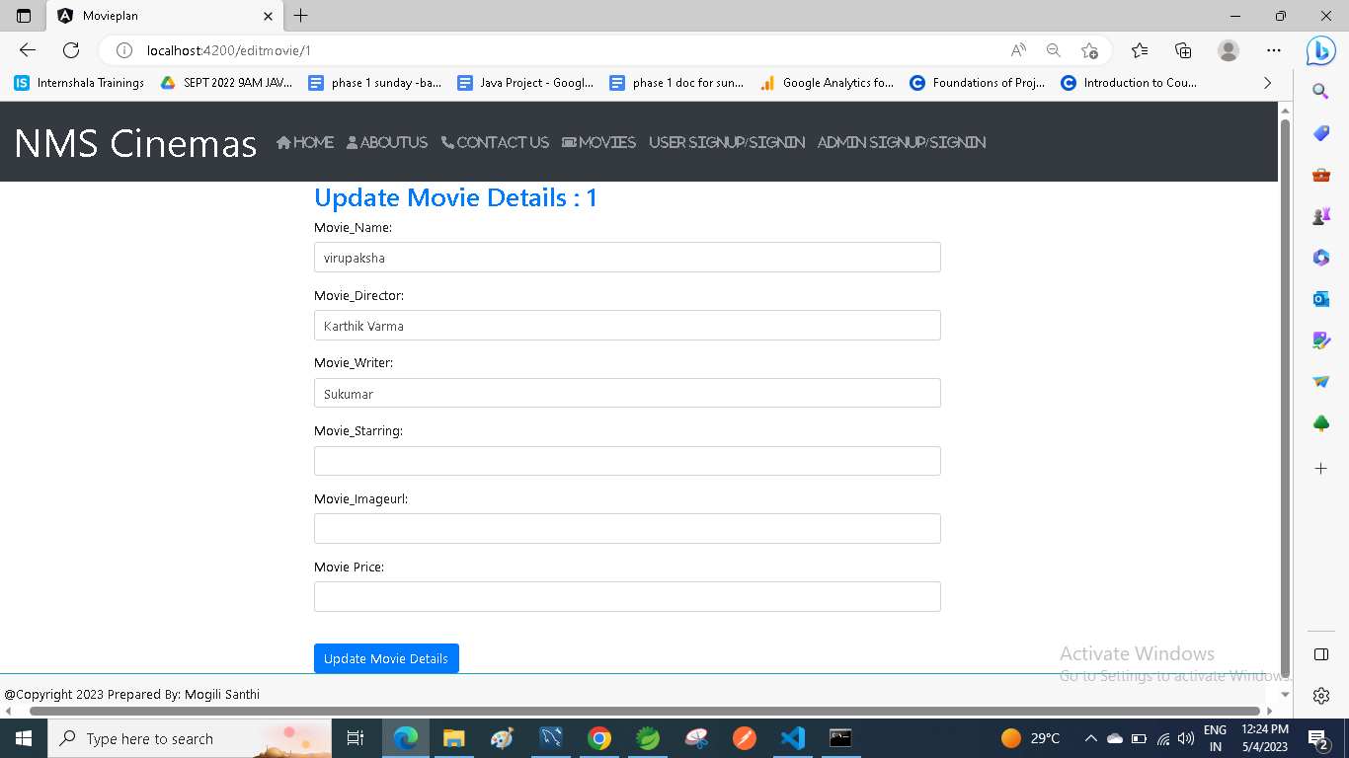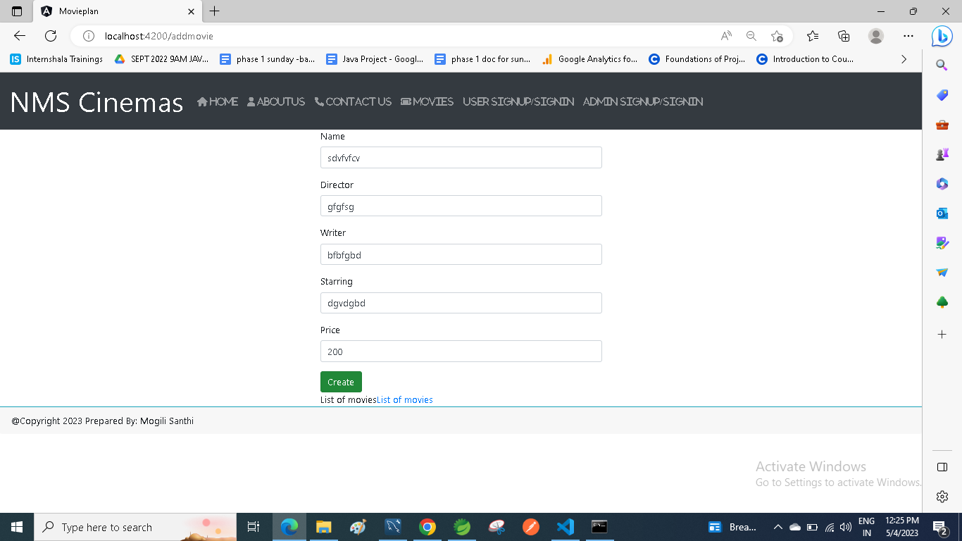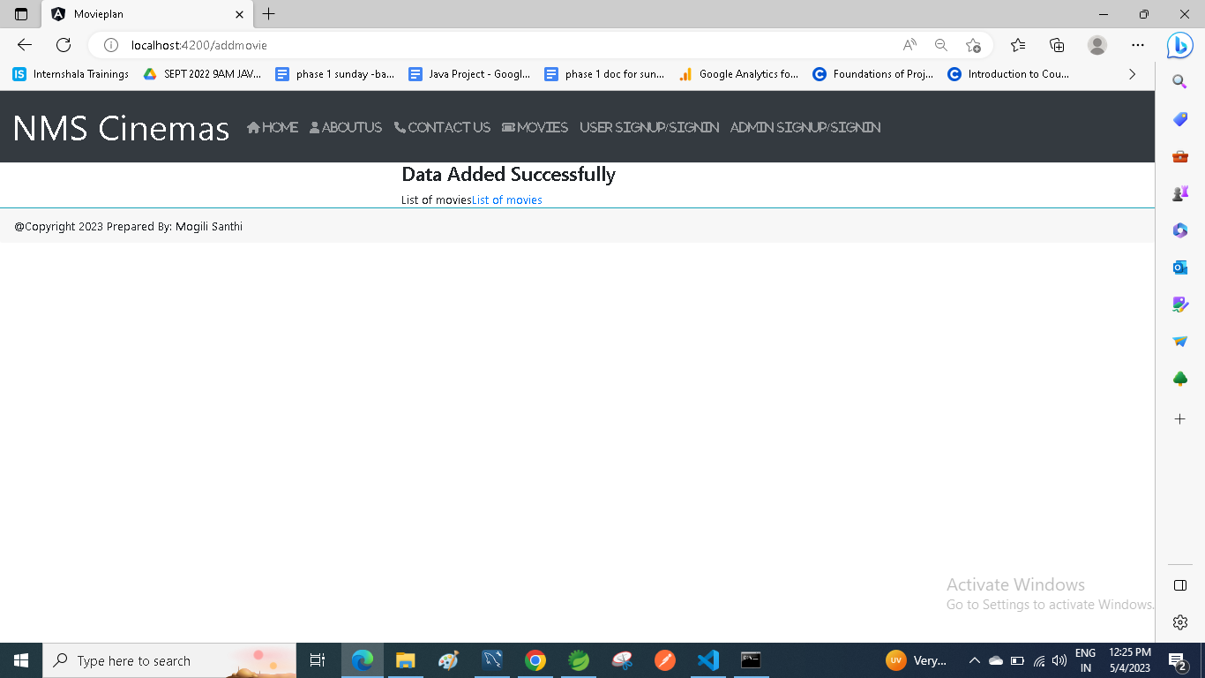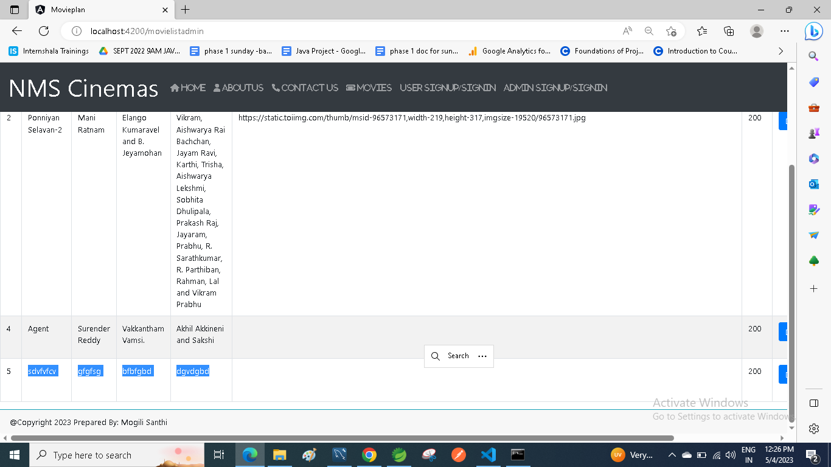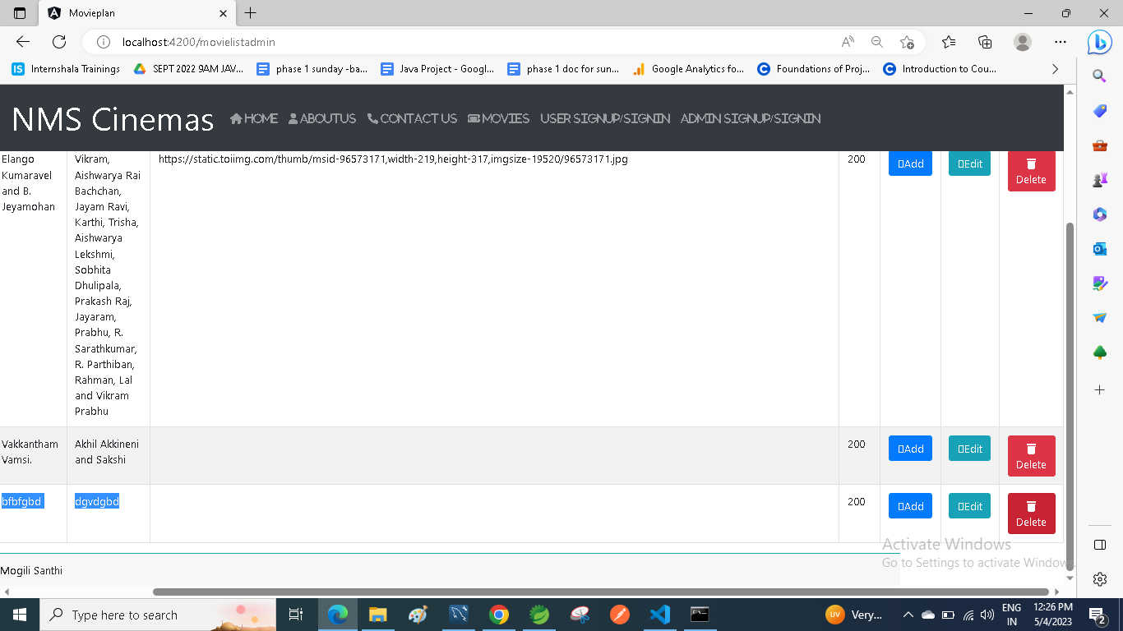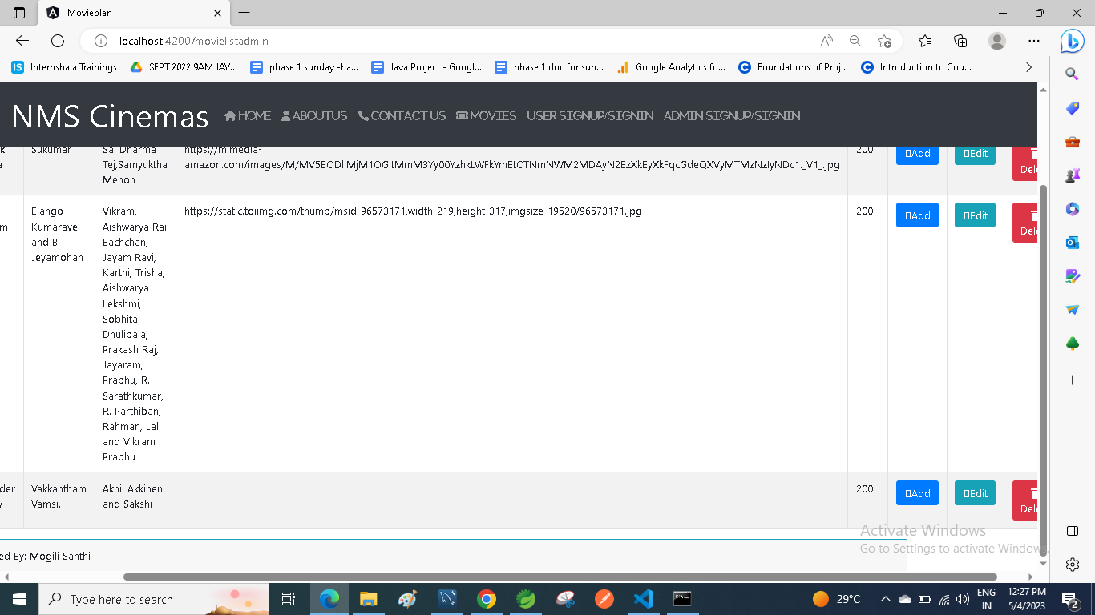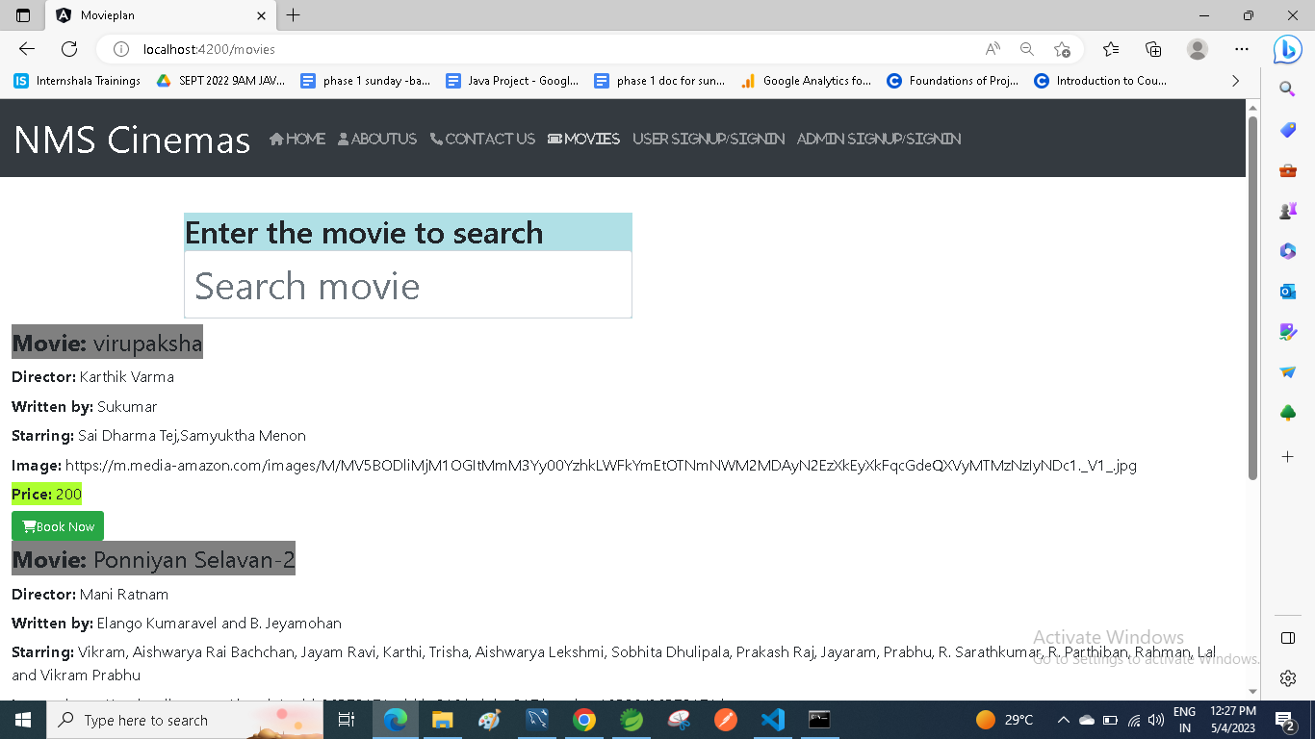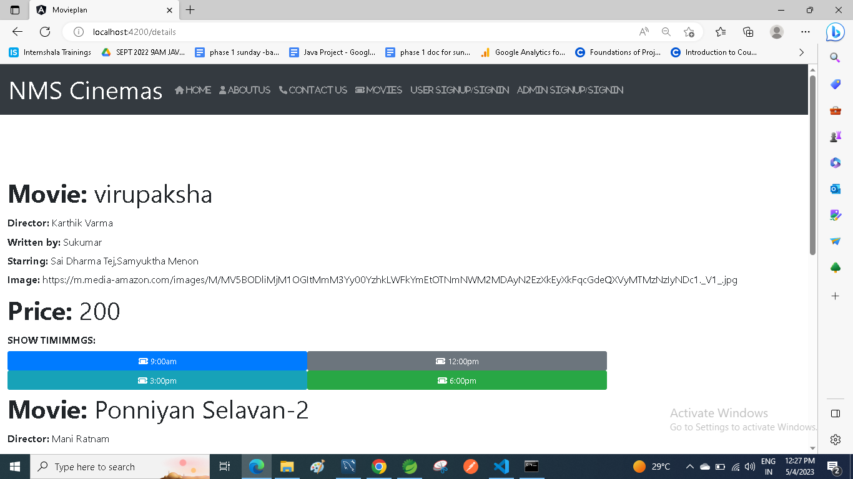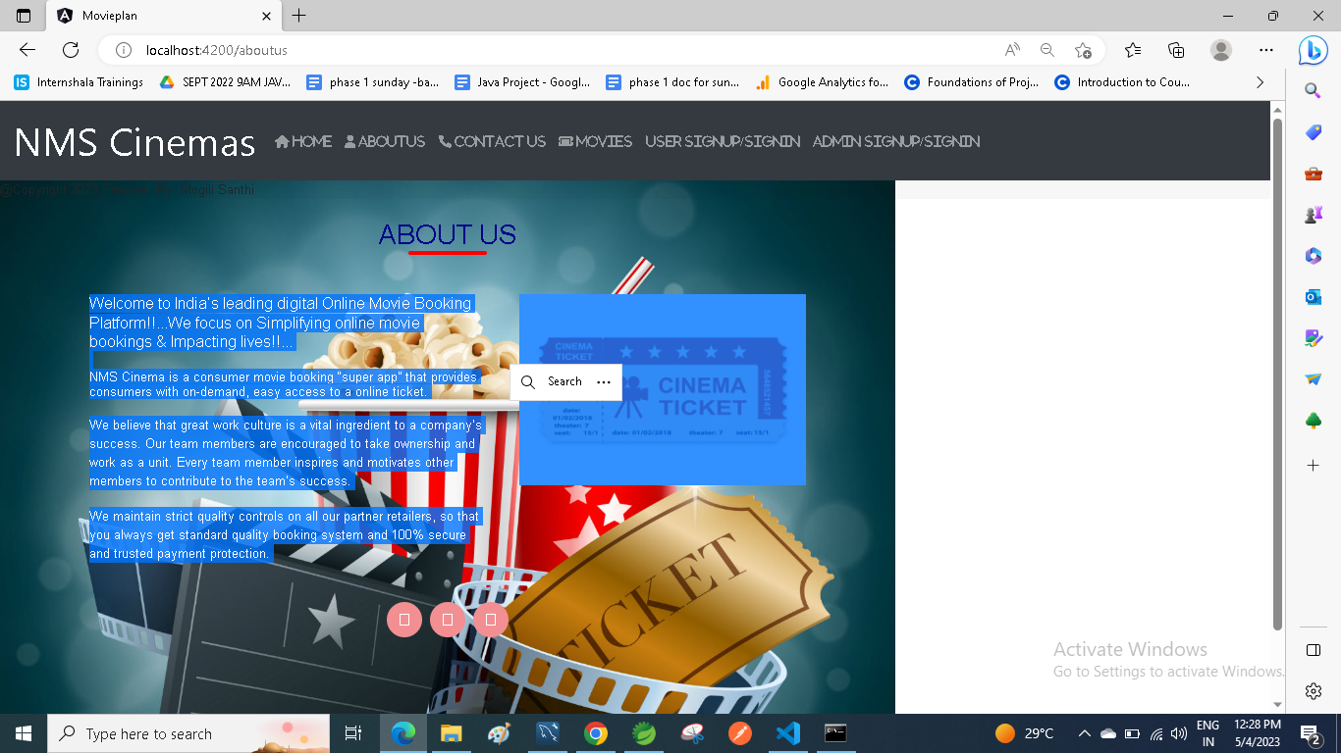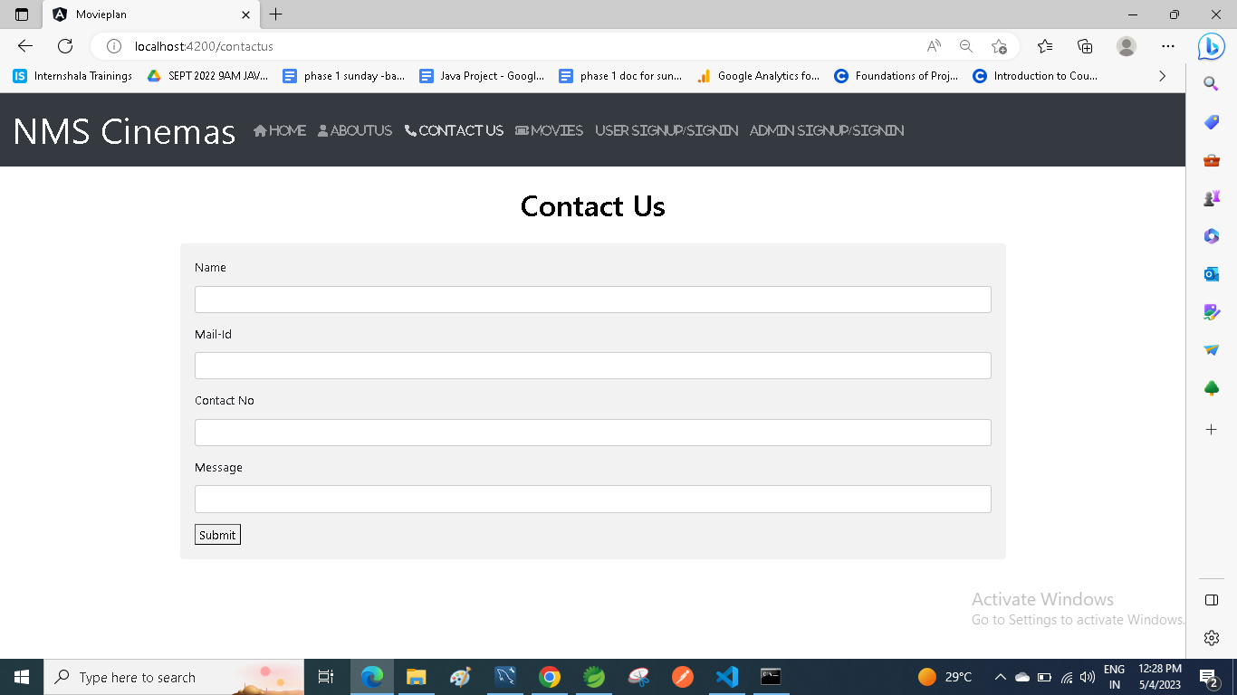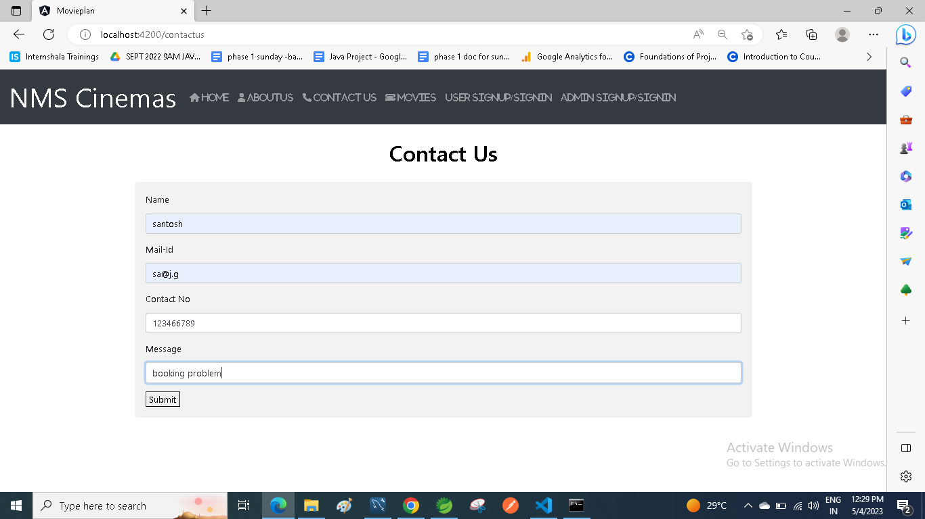

**Links to the GitHub repository to verify the project completion**

## **Pushing the code to GitHub repository**

* Open your command prompt and navigate to the folder where you have created your files.

**cd <** **D:\Movieplan\File>**

* Initialize repository using the following command:

**git init**

* Remote add the repository using the following command

**https://github.com/Mogilisanthi/Simplilearn-Phase-6-Mevieplan_project.git**

* Add all the files to your git repository using the following command:

**git add .**

* Commit the changes using the following command:

**git commit . -m “Movieplan project”**

* Push the files to the folder you initially created using the following command:

**git push -u origin master**